**SALESFORCE PROJECT**

**MILKEASE**

* **Phase 6:   User Interface Development**

👉 Goal **:**  Make it user-friendly.

* **Lightning App Builder**:-
* Create "MILKEASE" App.

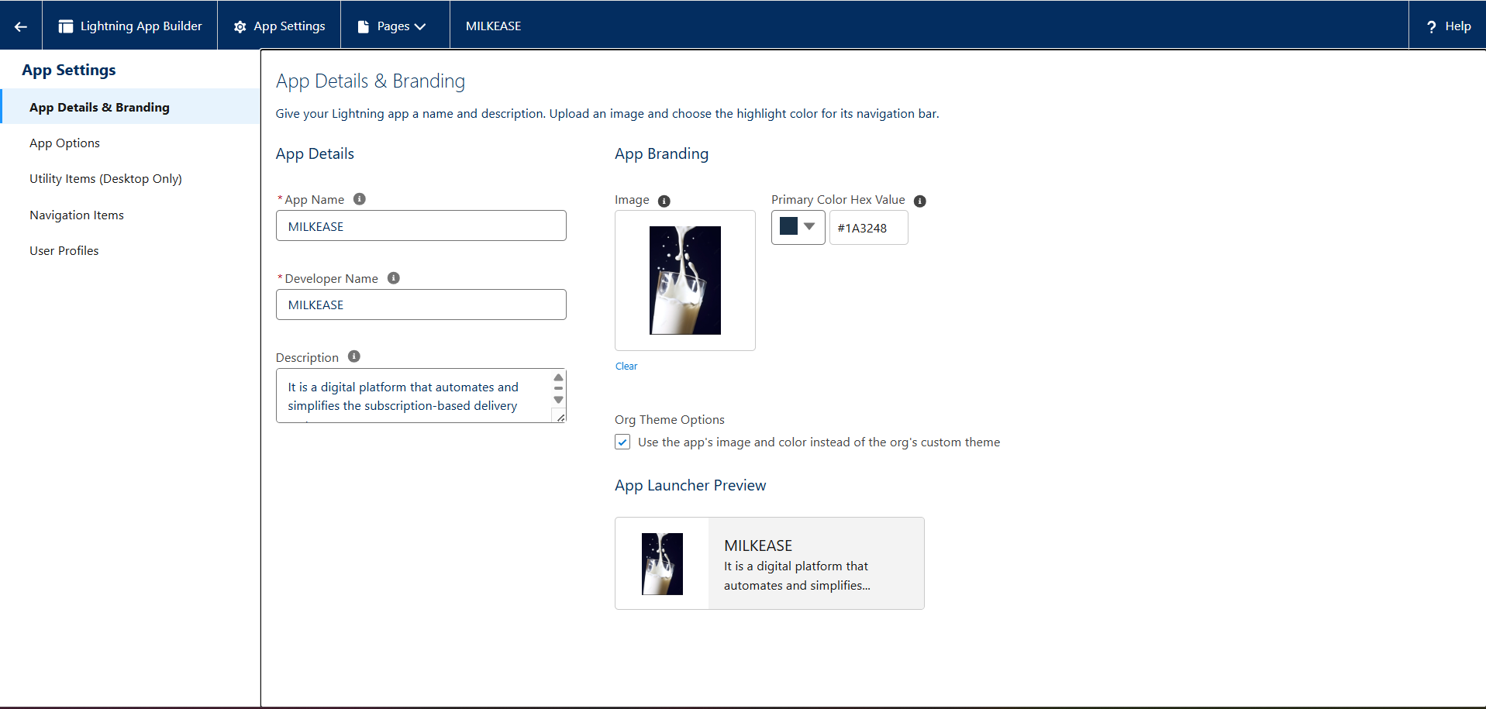

* Assign app to **profiles** (Manager, Delivery Agent, Customer Support).

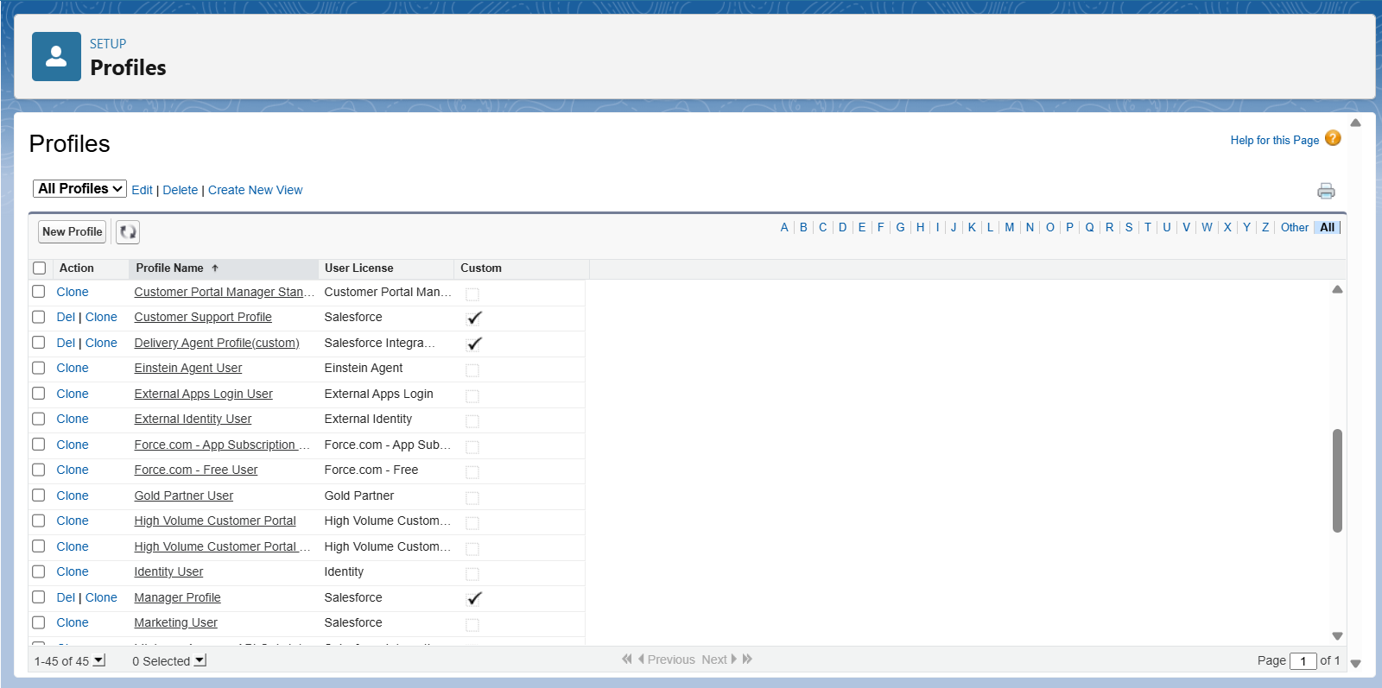

* Add objects as tabs:-

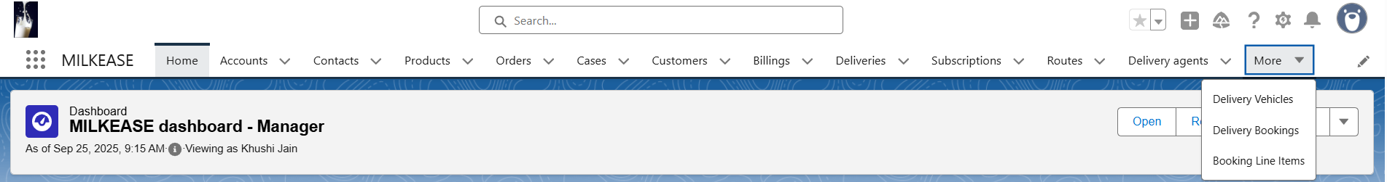

* **Record Pages**:-
* Customer record Page →

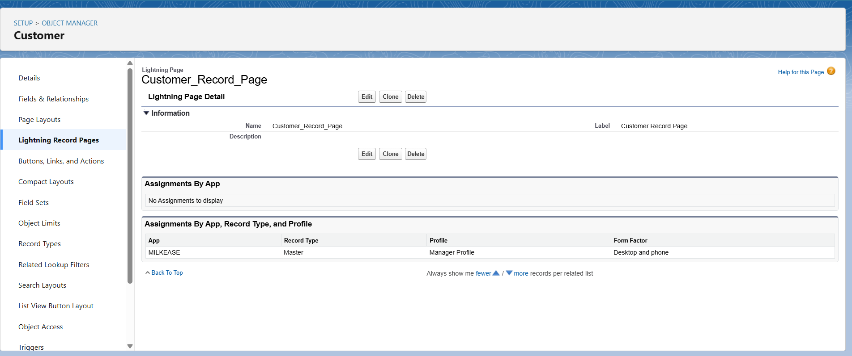

* Delivery Agent record Page →

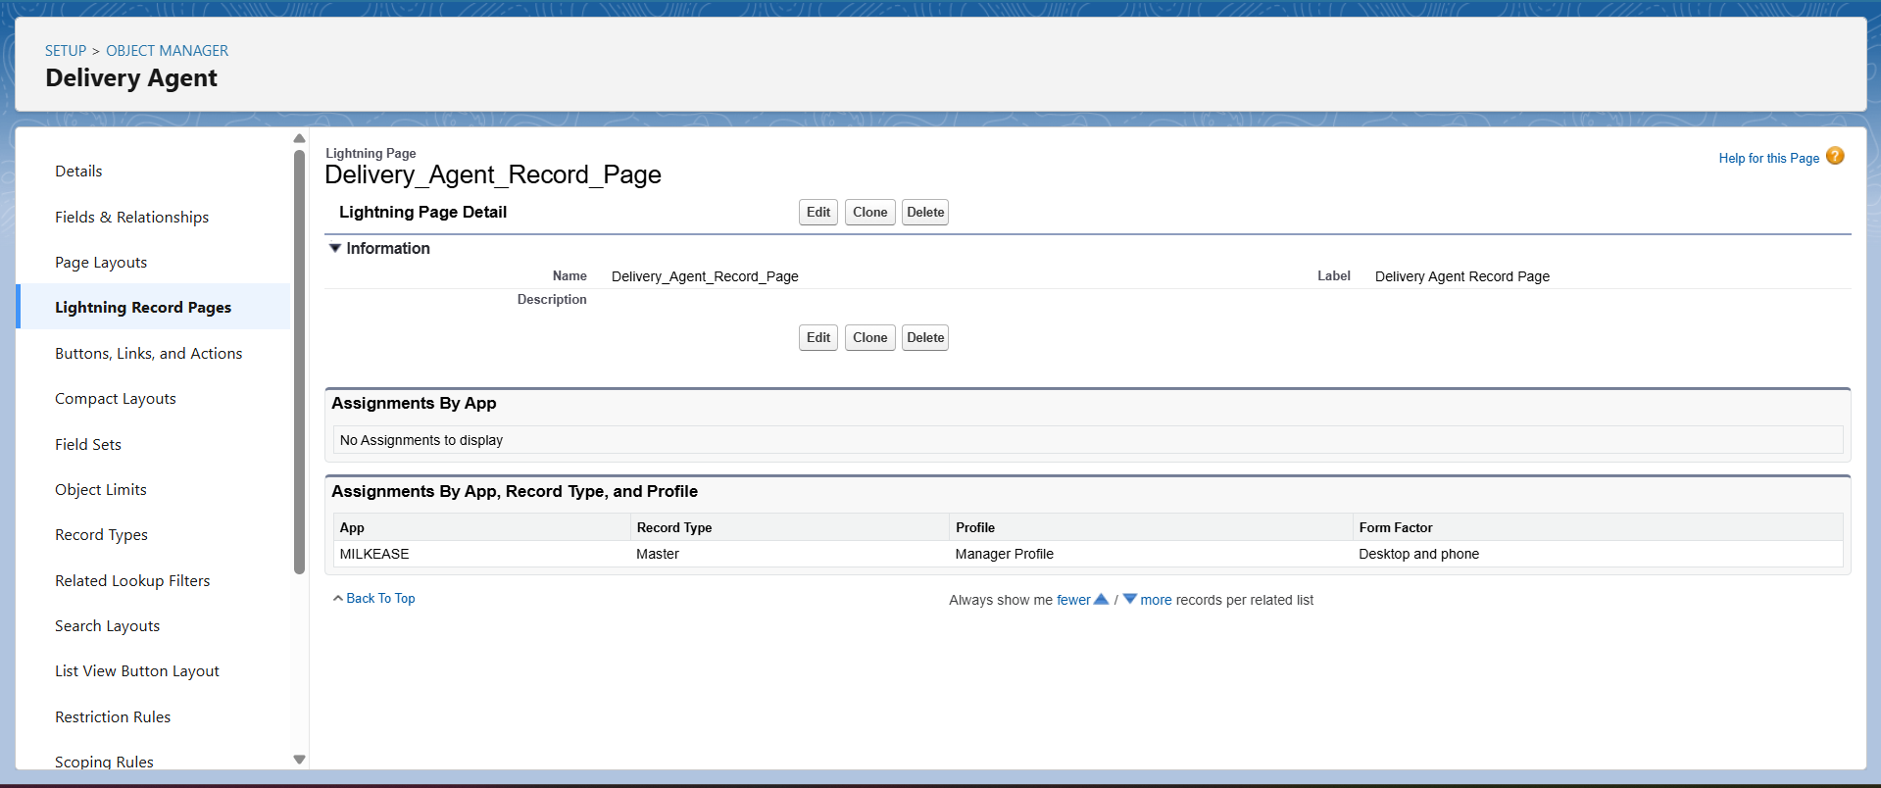

* Booking record Page →

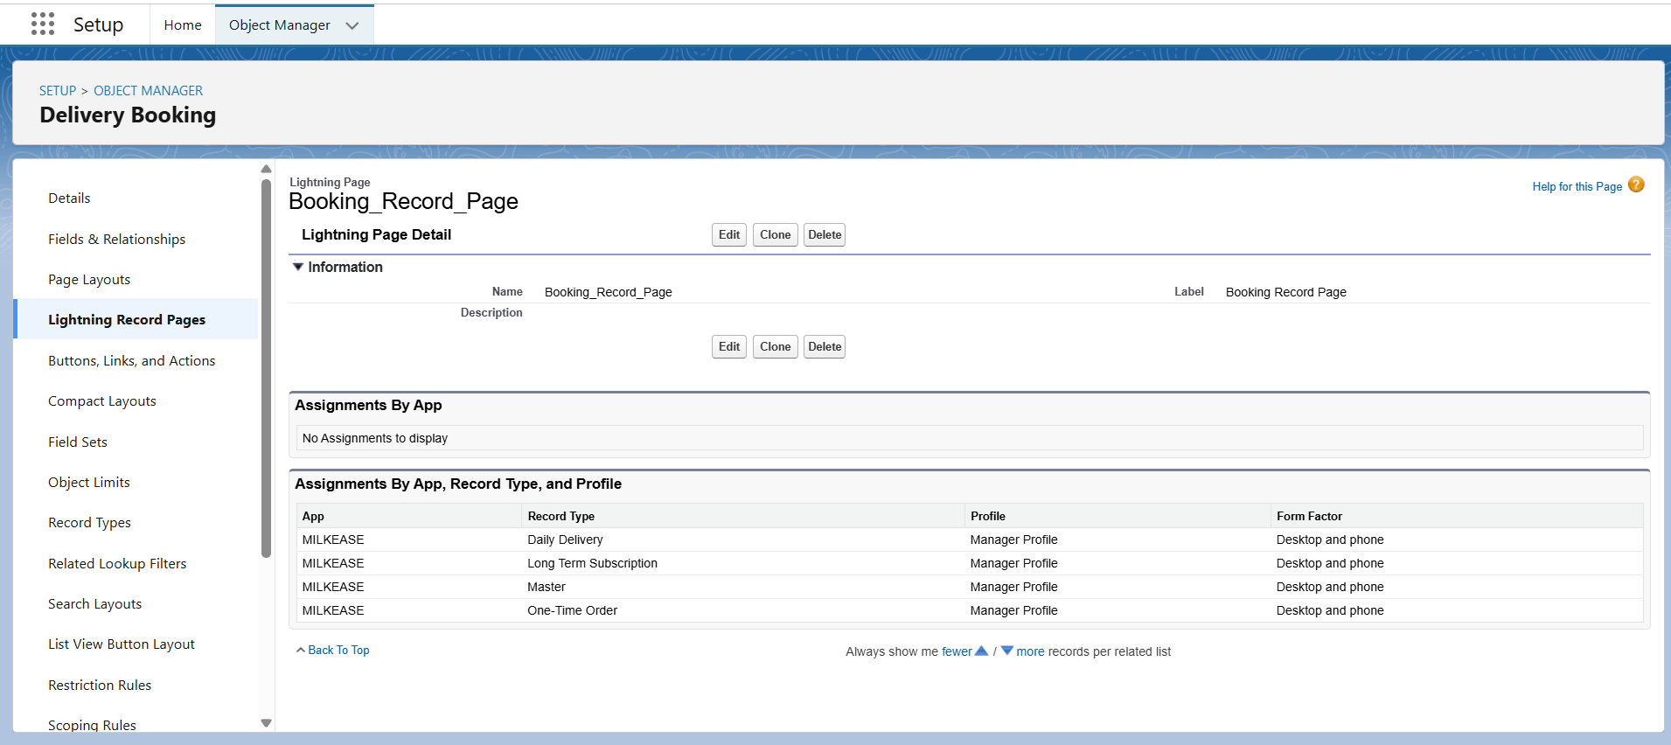

* **Home Page Layouts**:-
* Create a **Dairy Dashboard** (for Managers):
* Total Deliveries Today
* Active Customers
* Product-wise Quantity Chart (Milk vs Paneer vs Ghee)
* Delivery Agent Performance

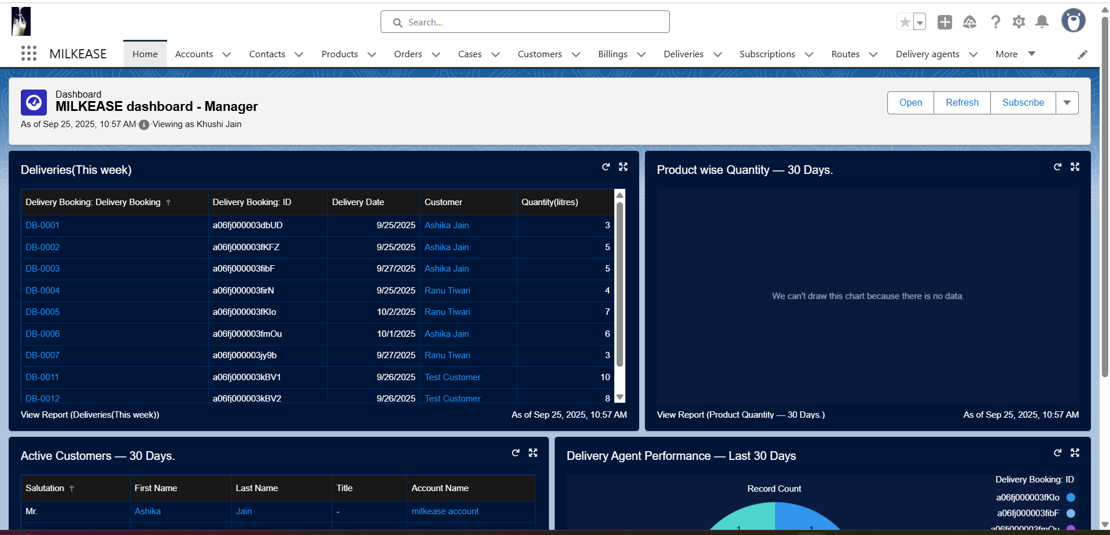

* **Utility Bar (Quick Actions)**:-
* Add **Quick Action: "New Contact"** → directly create a booking from anywhere.

